**Title: Summing Pyramids**

**Explanation:**  
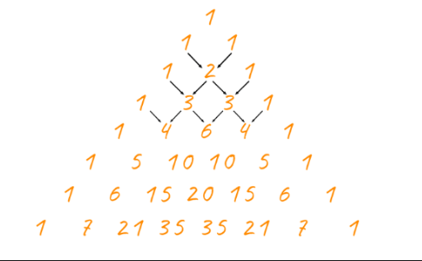

The pattern given below is the triangular array of numbers that begins with 1 on the top and with 1's running down the two sides of a triangle. Each new number lies between two numbers and below them, and its value is the sum of the two numbers above it.

The series S = 1,2,4,8,15,26,42, can be calculated by the first four column sum of each row of the.

**Object:**

Your object is to find the largest number in the series of “S” which is less than a given Number.

**Example Input: 20**  
**Output: 15**

(which is the largest number in the series which is less than the input number 30.)

**Example Input: 30**  
**Output: 26**

(which is the largest number in the series which is less than the input number 30.)

**Input Format**: integer

**Output format:** integer

**Constraints**: $30<input<{10}^{30}$